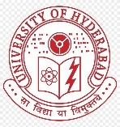 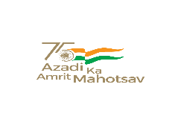 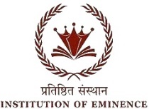

**BHARAT KA AMRIT MAHOTSAV**

UNIVERSITY OF HYDERABAD

SCHOOL OF COMPUTER AND INFORMATION SCIENCE

Collaboration with O/o Dean Student Welfare & O/o Chief Warden

Cordially invites you to Inaugural Function of Two days National Seminar on “BAM-2022“

Organized on 7th & 8th April 2022

INAUGRAL SESSION

**7th****April 9:30am to 1:00pm** **Venue:** **Vice Chancellor’s Conference Hall**

|  |  |  |
| --- | --- | --- |
| **Prayer & Lightning** | Lighting of lamp by Chief Guest | **9:30 – 9:40** |
| **Welcome Address BY** | Prof. D. Vijayalakshmi Garu  Chief warden, UoH | **9:40 – 9:50** |
| **Aims and Objectives** | Dr. M. Nagamani  Co-ordinator  Senior Assistant professor, SCIS, DCW | **9:50 – 10:00** |
| **Chairman** | Prof. Chakravati Bhagavati  Dean, SCIS | **10:00 – 10:10** |
| **Chief Guest** | Hon’ble Shri Ram Madav Garu  India Foundation | **10:10 – 10:20** |
| **Inaugural panel address** | Prof. B.J. Rao  VC University of Hyderabad  Prof R.S. Sarraju  Pro-Vice Chancellor. University of Hyderabad  Prof T V Kattimani  Vice Chancellor, CTUAP  Dr. Garikapati Narasimha Rao Garu  Noted Scholar & Padma Shree Awardee | **10:20 – 10:40**  **10:40 – 11:00**  **11:00 – 11:20**  **11:20 – 11:40** |
| **Guest of Honor** | Prof. P.G. Reddy Garu  Founder of Artificial Intelligence Lab, DCIS UOH  Prof. B. L. Deekshatulu (Padmashree awardee 1999)  Former ISRO scientist & Visiting Professor of SCIS  Dr. T. (S) Vishalakshi  Vice president of Veda Samskruthi Samithi  Head of the Sanathana Dharma | **11:40 – 12:00**  **12:00 – 12:10**  **12:10 – 12:20** |
| **Vote of Thanks** | Dr. Alok Kumar Pandey,  Anthropology Department, DCW | **12:20 – 12:30** |